How to Import a Report into PecStar using PecReport

- Start PecReport in PecStar iEMS.
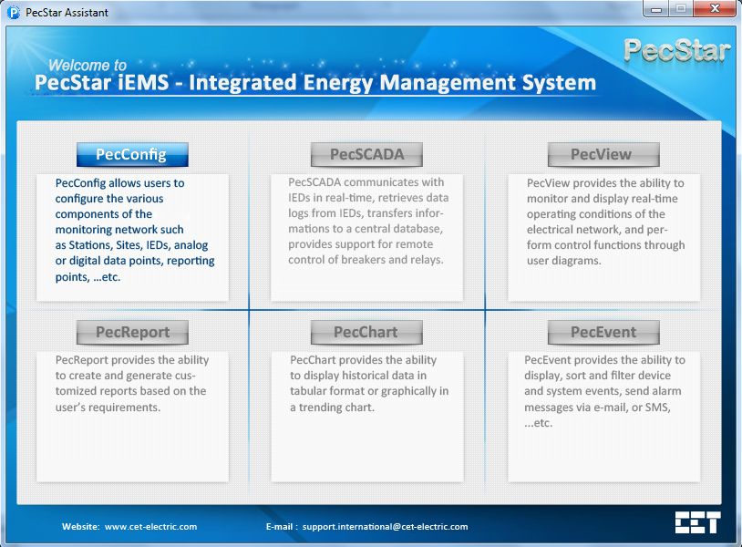

- Choose Edit Mode.
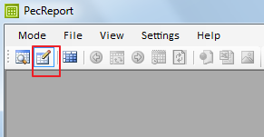

- Click File -> Import/Export.
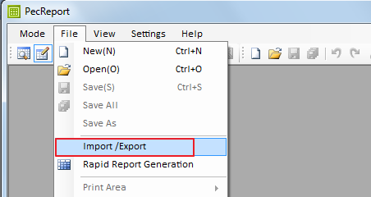

- Click Import Report, choose the root folder Report Library, then click Import.
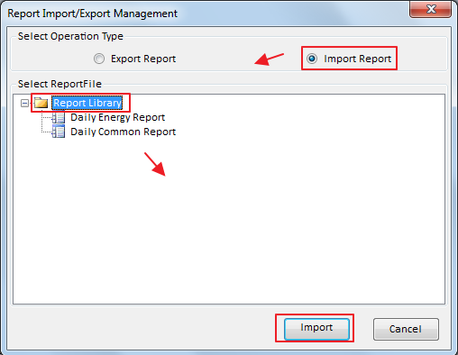

- Choose the report file and click Open.
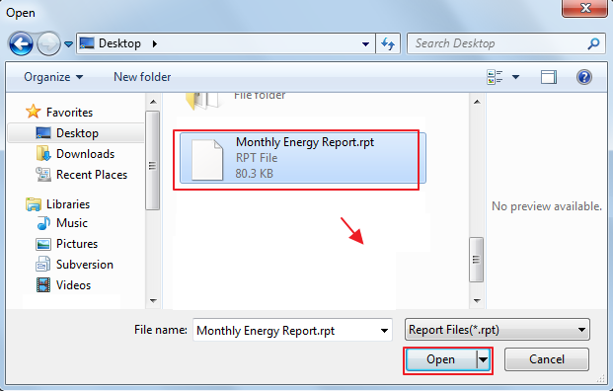

- Click OK when import successfully. This would be a little difference in description, since we may use different version of PecStar.
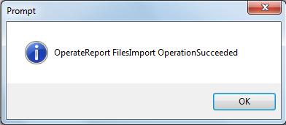

- Click Cancel to return to the main window. Now you can check the settings or switch to the Query Mode to view the report.
